**Term Project Milestone 1**

Milan Sherman

After reviewing some of the topics that were researched in *Everybody Lies* using Google Trend data, I began to brainstorm questions about various topics that might be answered using this type of data.

The Dallas Cowboys are often referred to as “America’s Team” (<https://www.bloggingtheboys.com/2020/5/11/21254504/cowboys-still-americas-team-whether-they-are-contenders-or-not>, 2020). *Are the Cowboys the most popular NFL team?* Some of the criteria I might use include the number of dimensions on which a team might be considered popular (searches for tickets, merchandise, game schedule, TV schedule), how widespread the popularity of a team is across the country, and how that popularity might change over time, and compare to other teams. In the visualization below, we see that compared with other popular football teams the Cowboys are not necessarily the most popular. We also observe a strong seasonality component in this data, and it may be important to investigate off-season searches to answer this question.

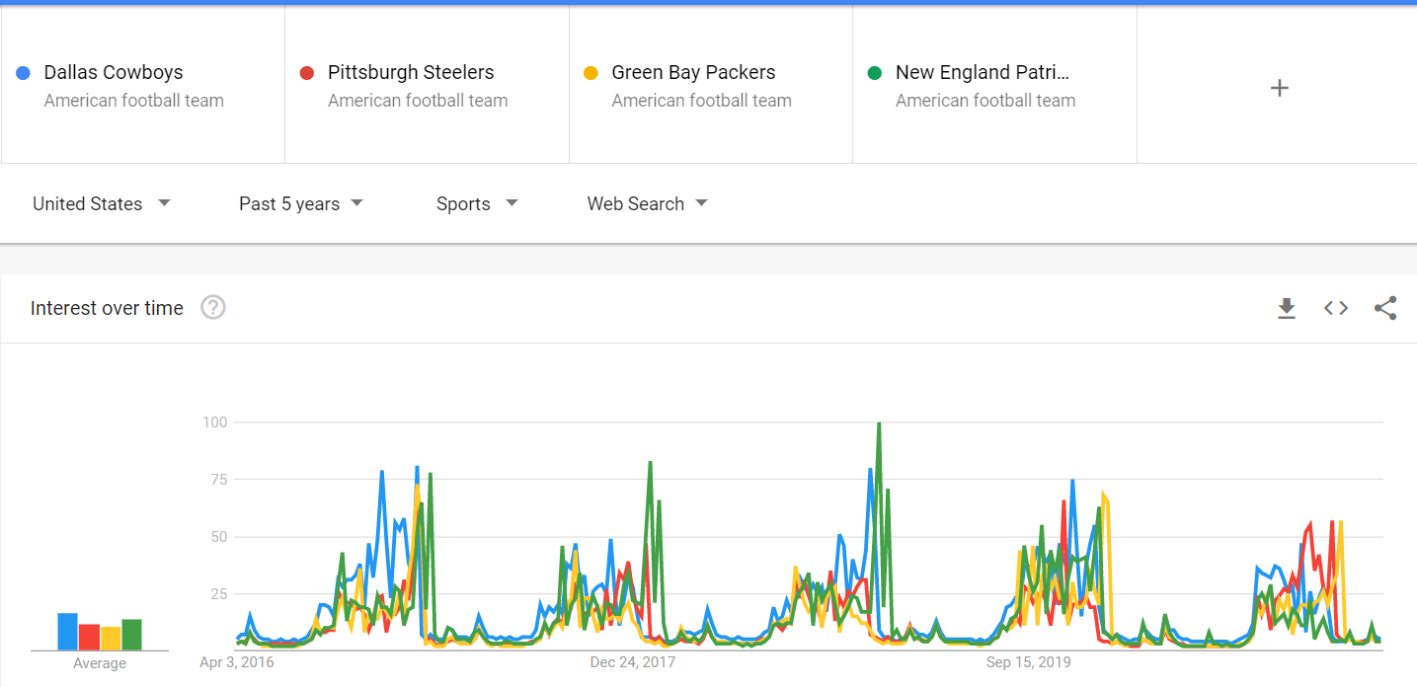

According to survey data, America is still predominantly a Christian country (<https://www.pewforum.org/2019/10/17/in-u-s-decline-of-christianity-continues-at-rapid-pace/>, 2019), with 65% of Americans identifying themselves as Christian. Given that this is based on survey data, I wonder, *Is America still a predominantly Christian country?* The criteria for answering this question are related to searches that would indicate someone is or is not Christian. For example, searches for questions related to the Christian faith vs. searches for questions related to other faiths. I think it will also be important to account for people who don’t identify with any religion, as this appears to be a growing percentage of the population. In the first visualization, we see that there has been more interest in Islam than Christianity over the last 5 years, however there has been much more interest in porn than in either Christianity or Islam (see the second visualization). As pornography is inconsistent with Christian moral principles, this suggests a much larger proportion of non-Christian people in the U.S. However, it is also likely the case that someone interested in religion is less likely to do a Google search for it than someone interested in porn. More work would need to be done to interpret these results.

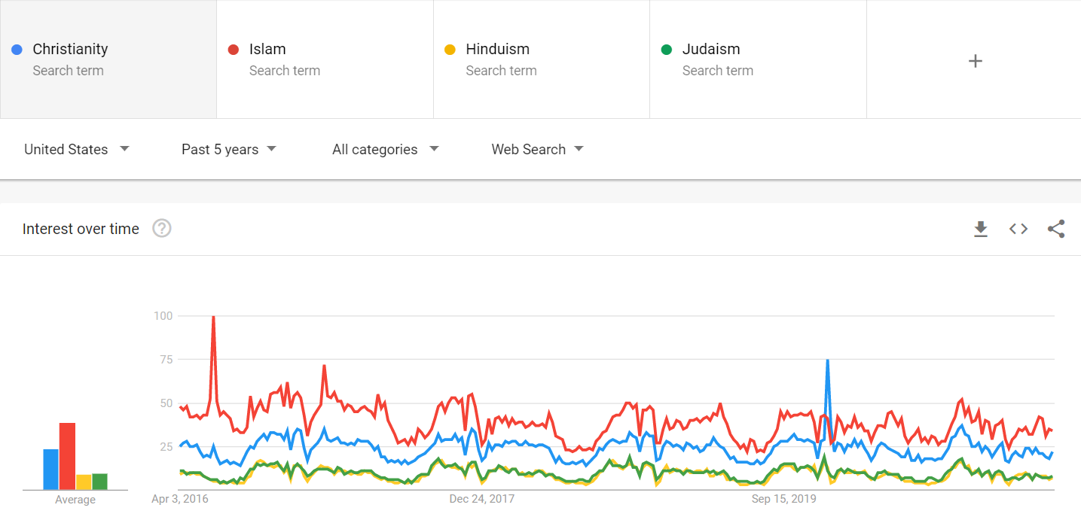

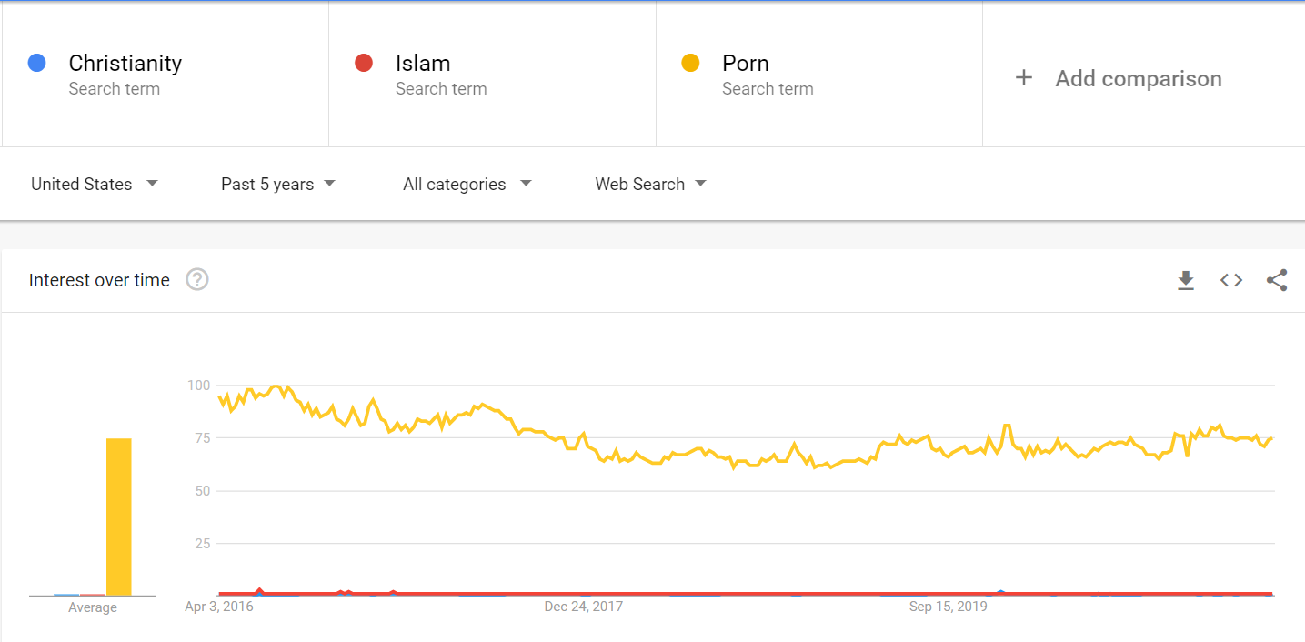

Most sports have cracked down on performance enhancing drug use (<https://recointensive.com/scandal-sports-use-performance-enhancing-drugs-professional-athletes/>, 2017). It has also been noted that cycling has the biggest PED problem (<https://www.tranquilshores.org/our-programs/athlete-rehab/guide-to-addiction-treatment-for-athletes/chapter-2-performance-enhancing-drugs-used-in-sp/#:~:text=Doping%20affects%20all%20sports%2C%20and,%2C%20boxing%2C%20triathlon%20and%20baseball>., n.d.; <https://www.cyclist.co.uk/news/2541/why-are-amateur-cyclists-taking-performance-enhancing-drugs>, 2018). *Has there been a decline in PED use in amateur cyclists*? This is a topic where people are likely not too be truthful in a survey, but perhaps search data can provide some insight. In The visualizations below shows that searches for the benefits of performance enhancing drugs commonly used in cycling has actually increased over time, in spite of these scandals and tightened control meaures:

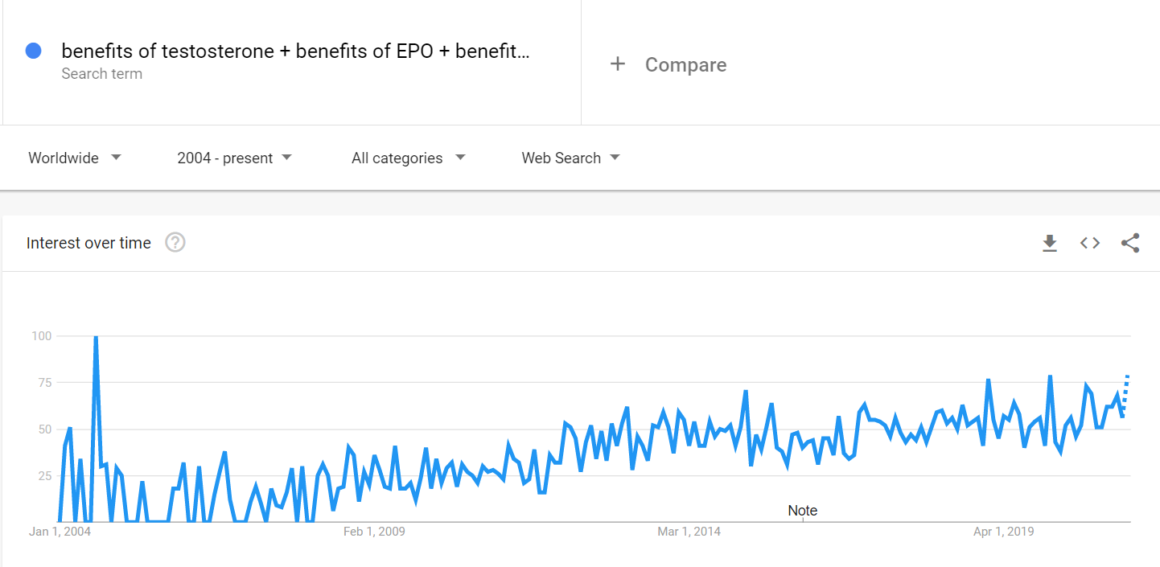

Given the number of people who lost their job during the COVID pandemic, *How many people changed careers during COVID?* Some sources are reporting that 2/3 of people who lost their job during the pandemic switched careers (<https://www.ksat.com/news/local/2021/02/05/more-people-are-switching-professions-because-of-pandemic/>, 2021). I would need to start with researching which industries saw a boon during the pandemic which would have provided an impetus for people to switch to a career related to that industry, and then research trends in searches for jobs or careers in those industries. In the first visualization below, we don’t necessarily see more interest in how to change careers during the last year. However, in the second visualization we see searches on this topic in the last 12 months highest in some of the states most locked down (California, Washington, New York). On the other hand we see Florida which was one of the most open states.

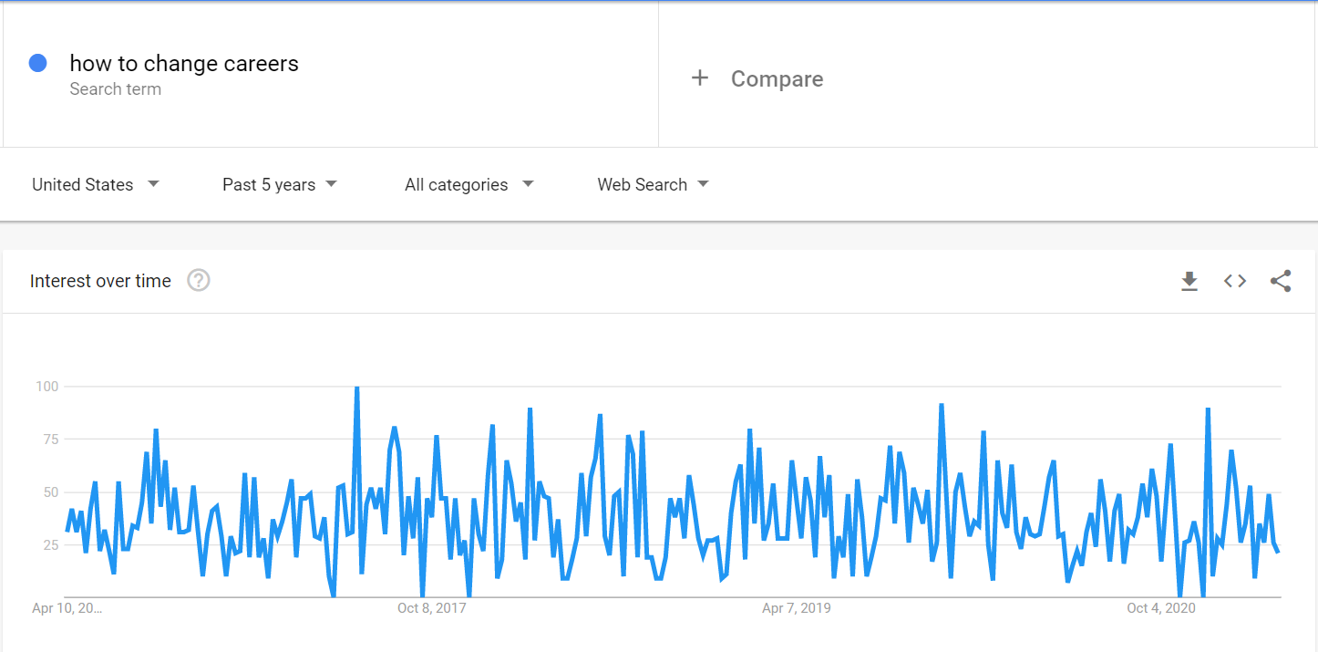

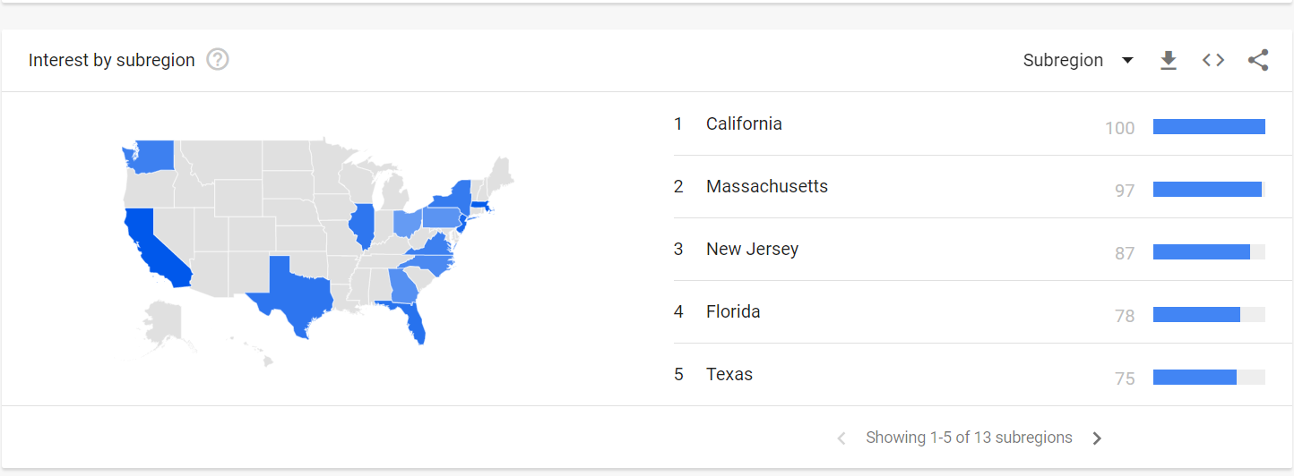

Regardless of which state you live in, there has been lots of criticism of lock down policies during the pandemic (<https://www.bbc.com/news/world-us-canada-52417610>, 2020; <https://ballotpedia.org/Debate_in_Iowa_over_responses_to_the_coronavirus_(COVID-19)_pandemic,_2020>, 2020). Which states’ citizens were least satisfied with their state’s lock down policies during the COVID pandemic? In this case, I would need to identify searches that would reveal dissatisfaction with lockdown policies by state. This might include the number of searches, but will also need to include the nature of those searches in order to separate questions about the policies from criticism of them. In the first visualization below, we see an uptick in searches for “worst governors” in the last 6 months, possibly as residents tired of their state’s lock down policy, or felt not enough was being done. In the second visualization, we see that the three states with enough searches to report were California, Florida, and Illinois. California has been criticized for being too strict, while Florida for not being strict enough, and Illinois for re-entering lock down just before Thanksgiving.

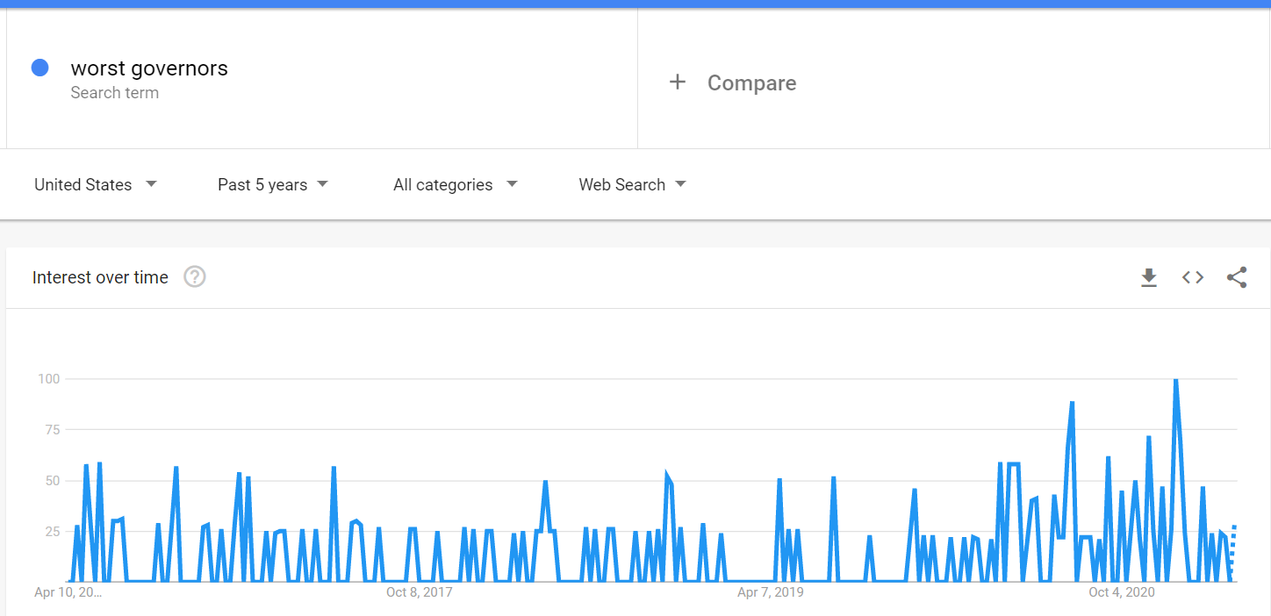

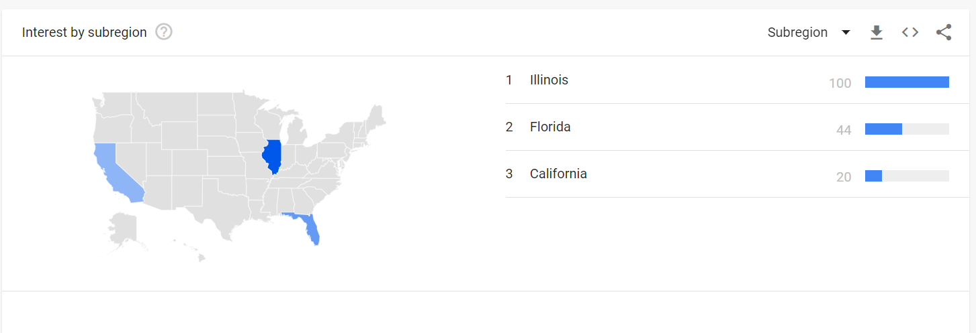

In all these cases, I found it difficult to identify searches that would be revealing of answers to these questions. However, I have decided to pursue the question about the use of performance enhancing drugs in amateur cycling as this is something I’m particularly interested in as an amateur cyclist, and found some interesting articles on this topic.

References

Chapter 2: Performance-enhancing drugs used in sports. (n.d.). Retrieved April 04, 2021, from https://www.tranquilshores.org/our-programs/athlete-rehab/guide-to-addiction-treatment-for-athletes/chapter-2-performance-enhancing-drugs-used-in-sp/#:~:text=Doping%20affects%20all%20sports%2C%20and,%2C%20boxing%2C%20triathlon%20and%20baseball.

Debate in Iowa OVER responses to the coronavirus (COVID-19) Pandemic, 2020. (2020, June). Retrieved April 03, 2021, from https://ballotpedia.org/Debate_in_Iowa_over_responses_to_the_coronavirus_(COVID-19)_pandemic,_2020

Halprin, D. (2020, May 11). Cowboys still America's team, whether they are CONTENDERS or not. Retrieved April 03, 2021, from https://www.bloggingtheboys.com/2020/5/11/21254504/cowboys-still-americas-team-whether-they-are-contenders-or-not

In U.S., decline of CHRISTIANITY continues at rapid pace. (2020, June 09). Retrieved April 03, 2021, from https://www.pewforum.org/2019/10/17/in-u-s-decline-of-christianity-continues-at-rapid-pace/

Maqbool, A. (2020, April 27). Coronavirus: The US resistance to a continued lockdown. Retrieved April 03, 2021, from https://www.bbc.com/news/world-us-canada-52417610

More people are switching professions because of pandemic. (2021, February 05). Retrieved April 03, 2021, from https://www.ksat.com/news/local/2021/02/05/more-people-are-switching-professions-because-of-pandemic/

Use of performance-enhancing drugs by professional athletes. (2020, January 29). Retrieved April 03, 2021, from <https://recointensive.com/scandal-sports-use-performance-enhancing-drugs-professional-athletes/>

Why are amateur cyclists taking performance-enhancing drugs? (2018, July 23). Retrieved April 04, 2021, from https://www.cyclist.co.uk/news/2541/why-are-amateur-cyclists-taking-performance-enhancing-drugs

* 1. Searches for Cowboys game tickets
  2. Searches for Cowboys game schedule
  3. Searches for Cowboys merchandise
  4. By geographical area
  5. Compare with other teams

* 1. How to become Christian (vs. Muslim, Jewish, Hindu, etc.)
  2. Christian churches near me (vs. mosques, synagogues, etc.)
  3. Who is Jesus (vs. who is Mohamed)